Determining the HUMAC NORM Servo and Motor Type

Procedure

If you have an original CYBEX NORM which was not upgraded with a HUMAC, you have a DM servo and Rockwell Motor. Proceed to Step 2 “Your System”.

If you have a NORM with a HUMAC System, continue with the following steps.

If you are running the current HUMAC2015 program, from the HELP menu, select ABOUT. The HUMAC will display your interface type (32 or 32/64-bit), and the System, Motor, and Servo.
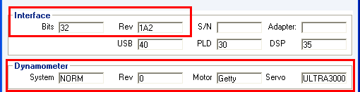
Figure 1 32-bit Interface

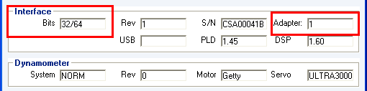
Figure 2 32/64-bit Interface

If you do not see the Interface and Motor, Servo information, or are running a previous version of the HUMAC, continue with the following steps.

Exit the HUMAC Program.

If you have a 32-bit Interface.
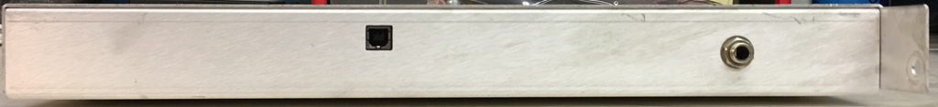
Figure 3 32-bit Interface

From the WINDOWS TASK BAR, select START, ALL PROGRAMS, HUMAC20??, UTILITIES, DIAGNOSTICS where HUMAC20?? Is your HUMAC version, e.g. HUMAC2004 or HUMAC20015.

From the STARTUP SCREEN, enter CSMIDIAG as the password and click the PROCEED WITH CAUTION button. The HUMAC will display the USB-DSP-PLD MONITOR form.

The USB-DSP-PLD MONITOR form will display the current Machine, Servo, Motor and Rev settings on the right-hand side of the screen.
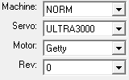

If you have the HUMAC 32/64-bit Interface
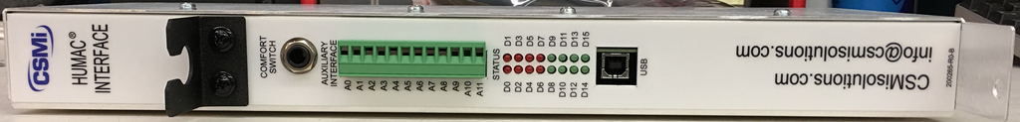
Figure 4 32/64-bit Interface

From the WINDOWS TASK BAR, select START, ALL PROGRAMS, HUMAC2015, UTILITIES, DIAGNOSTICS64.

From the STARTUP SCREEN, enter CSMIDIAG as the password and click the PROCEED WITH CAUTION button. The HUMAC will display the HUMAC64 DIAGNOSTICS form.

The DIAGNOSTICS form will display the current MACHINE, SERVO, MOTOR and REV settings on the right-hand side of the screen.
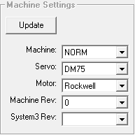

You can also determine the Motor type from the HUMAC Interface:
Rockwell Motor |  | Getty Motor
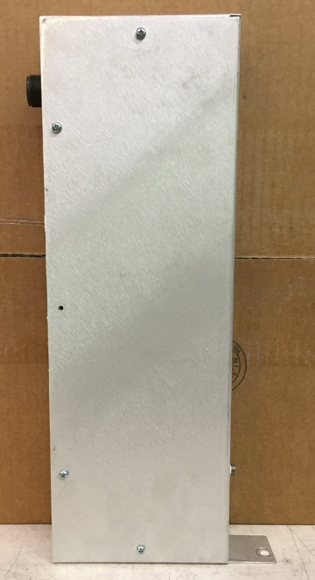 | 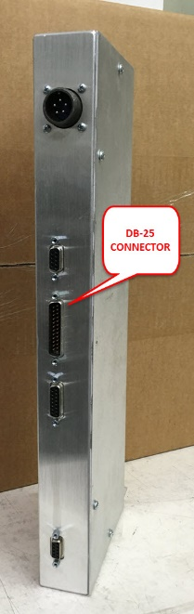 | 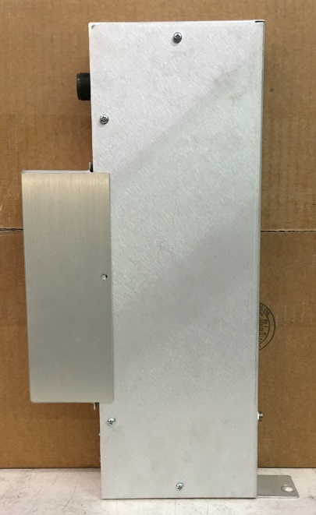 | 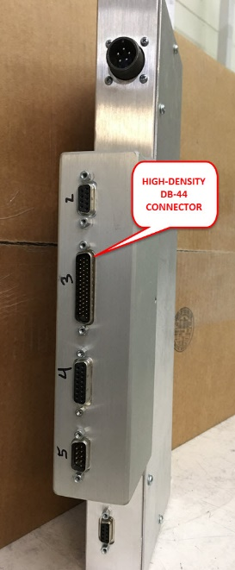

Click the Exit button to exit the diagnostics.

Your System

Check the setting for your system.
Item | Type
HUMAC Interface | 32-bit, 64-bit
Servo | DM-30, DM-75, Ultra3000
Motor | Rockwell, Getty

Complete the contact information below and FAX (781-297-2039) or e-mail (orders@csmisolutions.com) this page to CSMi.
Facility Name:
Street:
City, State:
Country:
Your Name:
Phone:
E-Mail:

Update the document with this information.

HUMAC Interface

Windows Compatibility
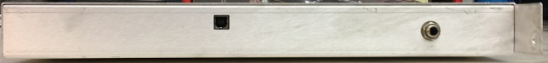 | 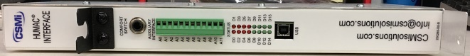
32-bit Windows Compatible Interface | 32 and 64-bit Windows Compatible Interface

Servo Enclosure Compatibility
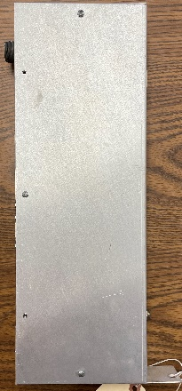 | 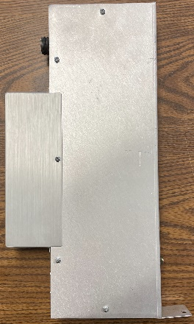
Compatible with DM Servo Enclosure Cabling. Note: Enclosure May Contain DM or Ultra3000 Servo with Upgrade Kit | Compatible with Ultra3000 Enclosure Cabling and Ultra3000 Servo

Servo Amplifiers
The following servo amplifiers have been used with NORM systems.

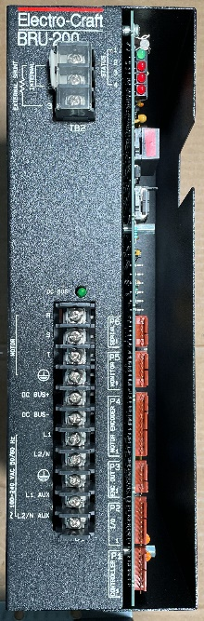 | 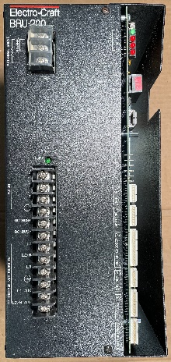 | 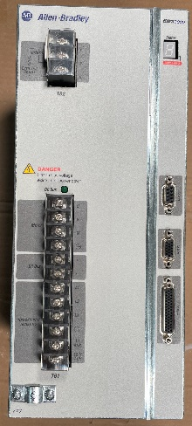 | 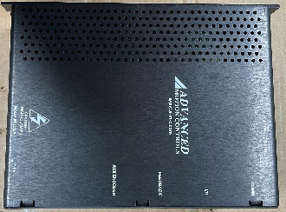
Rockwell  DM-30 | Rockwell  DM-75 | Rockwell  Ultra3000 | AMC  C060A400 | AMC  C060L400
Approx 3” wide | Approx 6” wide |  | Three large green connectors on the side | Two large green connectors on the side

Motors
The following motors have been used with NORM systems.

Rockwell motor.  - Green or Blue paint. | 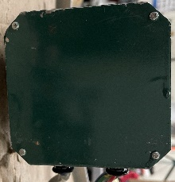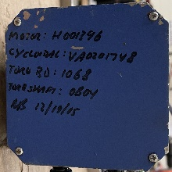
Getty motor.  - Black paint.  - Cooling fins are not visible at the back of the motor.  - Manufacturer’s label is not visible. | 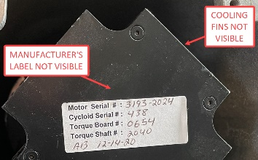
507202 motor.  - Black paint.  - Cooling fins are visible at the back of the motor.  - Manufacturer’s label is visible. | 

